Curso de Vagrant
Jackson Pires

Aula 01 – O que é e para que serve o Vagrant

O Vagrant permite ter mais de um ambiente com diferentes configurações (banco de dados, linguagem de programação, etc.) para trabalhar em sua máquina. Também permite distribuir esse ambiente (box) para outras pessoas que trabalham em um projeto. Pode ser criado um box para cada projeto.

Aula 02 – Requisitos para o uso do Vagrant

- virtual box (virtualizador)
- vagrant
- putty

- Inicialmente instale o Virtual Box.

https://www.virtualbox.org/wiki/Downloads

Aula 03 – Instalando no Windows

Baixar e instalar:

vagrant

https://www.vagrantup.com/downloads.html

putty
puttygen

https://www.chiark.greenend.org.uk/~sgtatham/putty/latest.html

Para acessar o Vagrant, depois de instalado, é necessário conectá-lo através de uma seção ssh e o Windows não tem esse serviço por padrão, e para isso é usado o putty.

puttygen é usado para gerar a chave de acesso (pública e privada).

vagrant -v

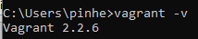

Aula 04 – O que é e onde encontrar boxes do Vagrant

https://www.vagrantbox.es/

ou

https://app.vagrantup.com/boxes/search

Aula 05 – Configurando/Instalando uma nova box

To use the available boxes just replace {title} and {url} with the information in the table below.

$ vagrant box add {title} {url}
$ vagrant init {title}
$ vagrant up

vagrant box add trusty64 https://cloud-images.ubuntu.com/vagrant/trusty/current/trusty-server-cloudimg-amd64-vagrant-disk1.box

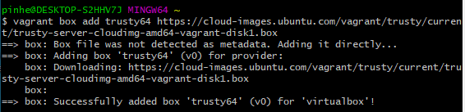

vagrant init trusty64

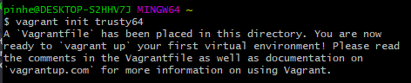

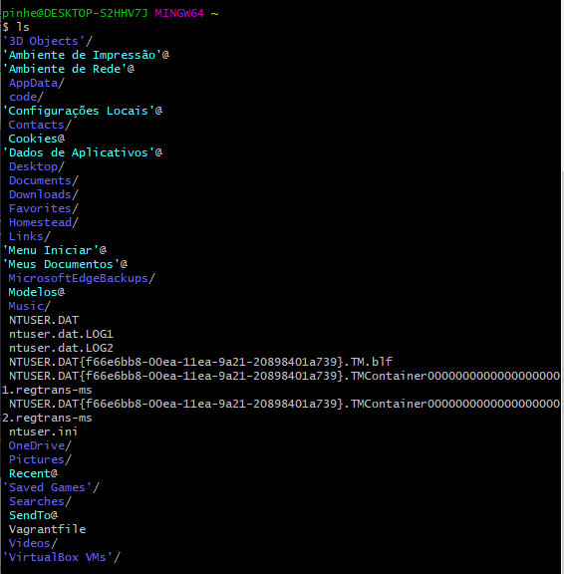

Vagrantfile

# -*- mode: ruby -*-
# vi: set ft=ruby :

# All Vagrant configuration is done below. The "2" in Vagrant.configure
# configures the configuration version (we support older styles for
# backwards compatibility). Please don't change it unless you know what
# you're doing.
Vagrant.configure("2") do |config|
# The most common configuration options are documented and commented below.
# For a complete reference, please see the online documentation at
# https://docs.vagrantup.com.

# Every Vagrant development environment requires a box. You can search for
# boxes at https://vagrantcloud.com/search.
config.vm.box = "trusty64"

# Disable automatic box update checking. If you disable this, then
# boxes will only be checked for updates when the user runs
# `vagrant box outdated`. This is not recommended.
# config.vm.box_check_update = false

# Create a forwarded port mapping which allows access to a specific port
# within the machine from a port on the host machine. In the example below,
# accessing "localhost:8080" will access port 80 on the guest machine.
# NOTE: This will enable public access to the opened port
# config.vm.network "forwarded_port", guest: 80, host: 8080

# Create a forwarded port mapping which allows access to a specific port
# within the machine from a port on the host machine and only allow access
# via 127.0.0.1 to disable public access
# config.vm.network "forwarded_port", guest: 80, host: 8080, host_ip: "127.0.0.1"

# Create a private network, which allows host-only access to the machine
# using a specific IP.
# config.vm.network "private_network", ip: "192.168.33.10"

# Create a public network, which generally matched to bridged network.
# Bridged networks make the machine appear as another physical device on
# your network.
# config.vm.network "public_network"

# Share an additional folder to the guest VM. The first argument is
# the path on the host to the actual folder. The second argument is
# the path on the guest to mount the folder. And the optional third
# argument is a set of non-required options.
# config.vm.synced_folder "../data", "/vagrant_data"

# Provider-specific configuration so you can fine-tune various
# backing providers for Vagrant. These expose provider-specific options.
# Example for VirtualBox:
#
# config.vm.provider "virtualbox" do |vb|
# # Display the VirtualBox GUI when booting the machine
# vb.gui = true
#
# # Customize the amount of memory on the VM:
# vb.memory = "1024"
# end
#
# View the documentation for the provider you are using for more
# information on available options.

# Enable provisioning with a shell script. Additional provisioners such as
# Puppet, Chef, Ansible, Salt, and Docker are also available. Please see the
# documentation for more information about their specific syntax and use.
# config.vm.provision "shell", inline: <<-SHELL
# apt-get update
# apt-get install -y apache2
# SHELL
end

Ou, em https://app.vagrantup.com/boxes/search faça o download do arquivo trusty_64.box e:

vagrant box add trusty64 trusty_64.box
vagrant init ubuntu/trusty64
vagrant up

Aula 06 – Iniciando e acessando uma nova box

Gerando as chaves ssh

- Execute puttygen.

- Clique no botão "Load"

- Carregar o arquivo insecure_private_key na pasta C:\Users\pinhe\.vagrant.d

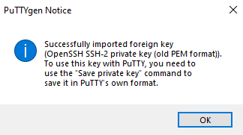

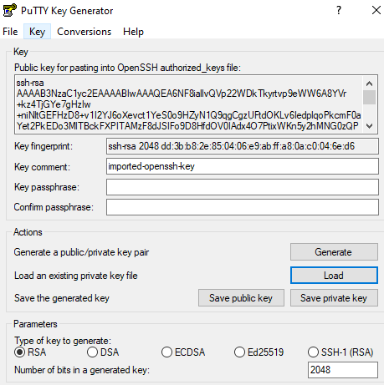

E clique no botão "Save private key".

- Salve com o nome de vagrant.

- Será criado nessa mesma pasta, um arquivo chamado vagrant.ppk

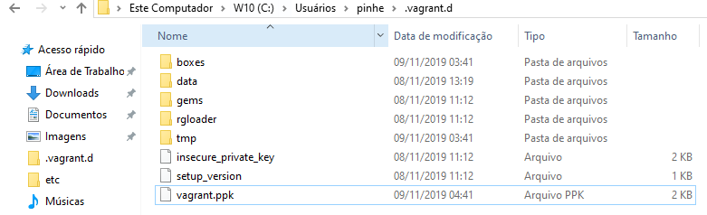

Instalando o plugin vbguest

- Agora é necessário instalar um plugin para que o Vagrant faça a gerência do guest edition, que é um programa que vai fazer com que a máquina virtual converse com a máquina real (host).

O guest edition é dependente da versão do Virtual Box que está sendo usada.

vagrant plugin install vagrant-vbguest

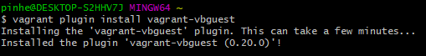

Levantando a máquina virtual

No Linux e no mac:

vagrant up
vagrant ssh

No Windows:

vagrant up

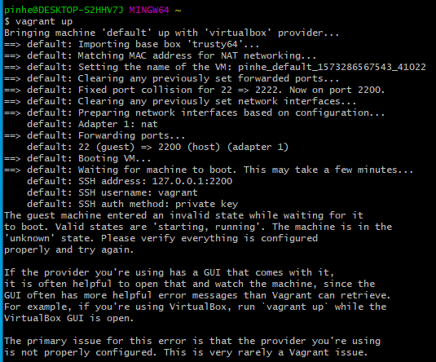

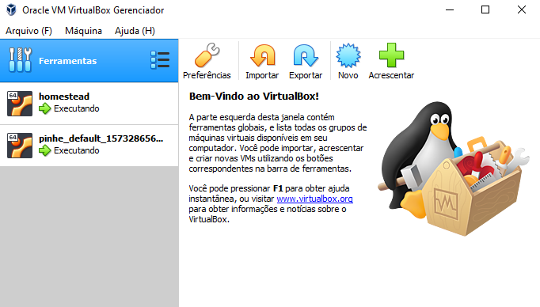

- Execute o putty com as seguintes informações:

- Em Session:

Host Name (or IP address): 127.0.0.1:2200

Connection type: SSH

- Em Connection Data:

auto login username: vagrant

- Em Connection → SSH → Auth → Private key file authentication:

- Clique no botão Browse e entre com:

C:\Users\pinhe\.vagrant.d\vagrant.ppk

- Salve a configuração em:

Session → Saved Sessions

Com o nome: vagrant

E clique no botão Save

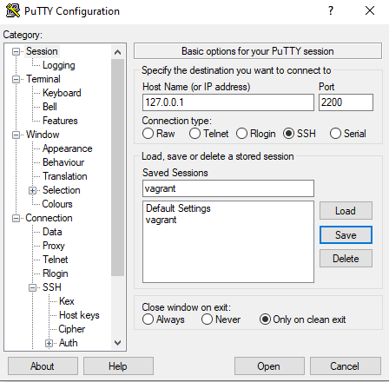

- Clique no botão Open.

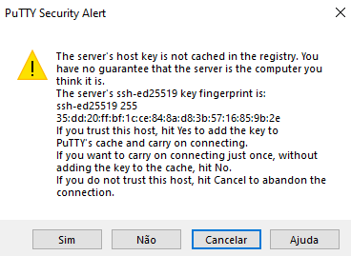

- Clique no botão "Sim"

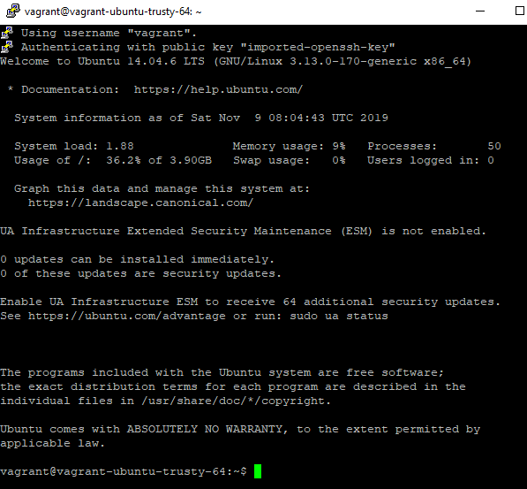

- Para desligar a máquina virtual:

vagrant halt

Aula 07 – Empacotando uma nova box para distribuir

Na pasta que contém o arquivo Vagrantfile entrar com os comandos:

vagrant up

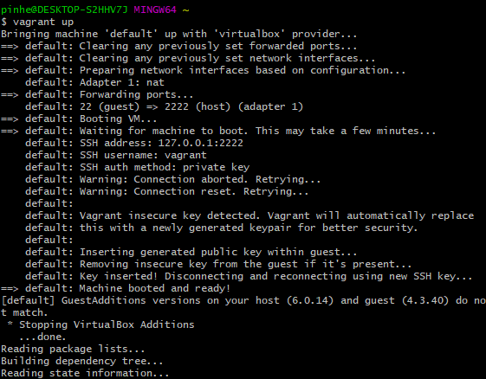

vagrant ssh

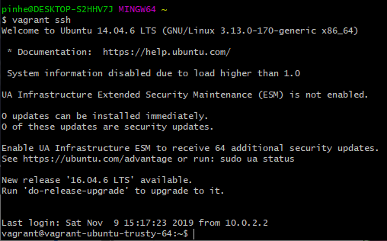

Instalando o git na máquina virtual

sudo apt-get install git

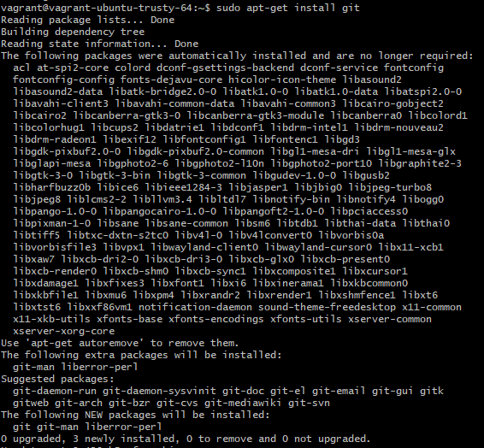

- Sair da máquina virtual e desligá-la.

exit

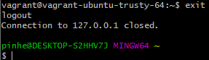

vagrant halt

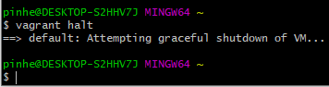

Empacotando

vagrant package --base pinhe_default_1573286567543_41022

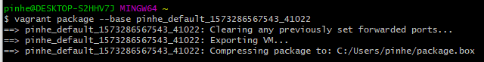

Será criado um arquivo chamado: package.box

Aula 08 – Considerações finais

Comandos mais usados

Para adicionar uma nova box

vagrant box add <arquivo.box>

Para criar o arquivo Vangratfile

vangrat init

Para levantar a box adicionada

vangrant up

Para acessar uma box

vagrant ssh

Para desligar uma box

vagrant halt

Para pausar uma box

vagrant suspend

Vangratfile

# -*- mode: ruby -*-
# vi: set ft=ruby :

# All Vagrant configuration is done below. The "2" in Vagrant.configure
# configures the configuration version (we support older styles for
# backwards compatibility). Please don't change it unless you know what
# you're doing.
Vagrant.configure("2") do |config|
# The most common configuration options are documented and commented below.
# For a complete reference, please see the online documentation at
# https://docs.vagrantup.com.

# Every Vagrant development environment requires a box. You can search for
# boxes at https://vagrantcloud.com/search.
config.vm.box = "trusty64"

# Disable automatic box update checking. If you disable this, then
# boxes will only be checked for updates when the user runs
# `vagrant box outdated`. This is not recommended.
# config.vm.box_check_update = false

# Create a forwarded port mapping which allows access to a specific port
# within the machine from a port on the host machine. In the example below,
# accessing "localhost:8080" will access port 80 on the guest machine.
# NOTE: This will enable public access to the opened port
# config.vm.network "forwarded_port", guest: 80, host: 8080

# Create a forwarded port mapping which allows access to a specific port
# within the machine from a port on the host machine and only allow access
# via 127.0.0.1 to disable public access
# config.vm.network "forwarded_port", guest: 80, host: 8080, host_ip: "127.0.0.1"

# Create a private network, which allows host-only access to the machine
# using a specific IP.
# config.vm.network "private_network", ip: "192.168.33.10"

# Create a public network, which generally matched to bridged network.
# Bridged networks make the machine appear as another physical device on
# your network.
# config.vm.network "public_network"

# Share an additional folder to the guest VM. The first argument is
# the path on the host to the actual folder. The second argument is
# the path on the guest to mount the folder. And the optional third
# argument is a set of non-required options.
# config.vm.synced_folder "../data", "/vagrant_data"

# Provider-specific configuration so you can fine-tune various
# backing providers for Vagrant. These expose provider-specific options.
# Example for VirtualBox:
#
# config.vm.provider "virtualbox" do |vb|
# # Display the VirtualBox GUI when booting the machine
# vb.gui = true
#
# # Customize the amount of memory on the VM:
# vb.memory = "1024"
# end
#
# View the documentation for the provider you are using for more
# information on available options.

# Enable provisioning with a shell script. Additional provisioners such as
# Puppet, Chef, Ansible, Salt, and Docker are also available. Please see the
# documentation for more information about their specific syntax and use.
# config.vm.provision "shell", inline: <<-SHELL
# apt-get update
# apt-get install -y apache2
# SHELL
end

